**1. Task Name:** How sales differ across various regions.

* **Status**: Completed
* **Tools Used**:
  + **Excel**: The sales data was initially stored in an csv file.
  + **Python Libraries**:
    - **Pandas**: Used for data manipulation and analysis.
    - **Matplotlib**: Used to create visualizations, including bar charts to represent sales across different regions.
* **Description**:  
  This task involved reading sales data from an csv file into Python, analyzing it using the Pandas library, and visualizing the results with a bar chart to understand how sales differ across various regions. The primary focus was on the number of products sold in each region.

**Steps and Process**

1. **Data Loading**:  
   The sales data was imported from an csv file into Python using Pandas.  
     
   
2. The relevant columns for analysis were Location (Region) and Number of Products Sold.

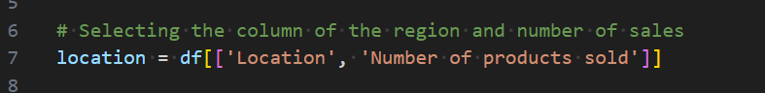

1. **Data Grouping and Analysis**:  
   The data was grouped by Location (Region), and the total number of products sold in each region was summed using Pandas' groupby() and sum() functions.  
     
   
2. **Data Visualization**:  
   A bar chart was created using Matplotlib to visualize how the number of products sold varies across different regions. This visualization helps identify which regions have the highest and lowest sales figures.

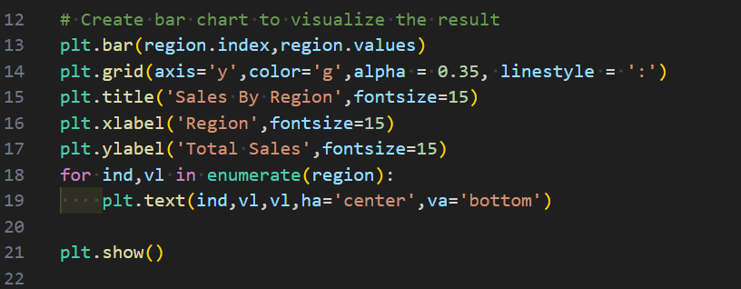

**Findings from the Bar Chart  
  
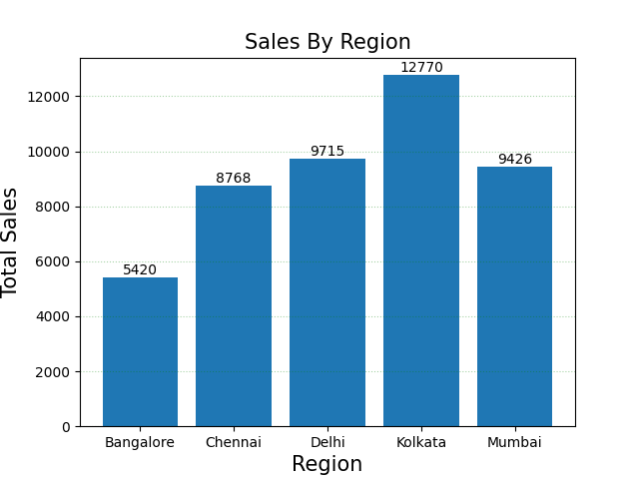**

* **Insight**: The bar chart provided a clear representation of how product sales differed across regions.
* **Observations**:
  + **Kolkata** recorded the highest number of product sales with (12770).
  + **Bangalore** had significantly lower sales with (5420), suggesting potential opportunities for improvement or further investigation.
  + Other regions showed moderate sales, with some variability that may warrant deeper analysis.

**Next Steps**

* **Further Analysis**: Investigate why certain regions have lower sales and identify any potential factors affecting performance.
* **Action Plan**: Share the results with the team to discuss potential marketing strategies for underperforming regions.
* **Reporting**: Finalize the report and add additional visualizations if required for more comprehensive insights.

**SQL:**

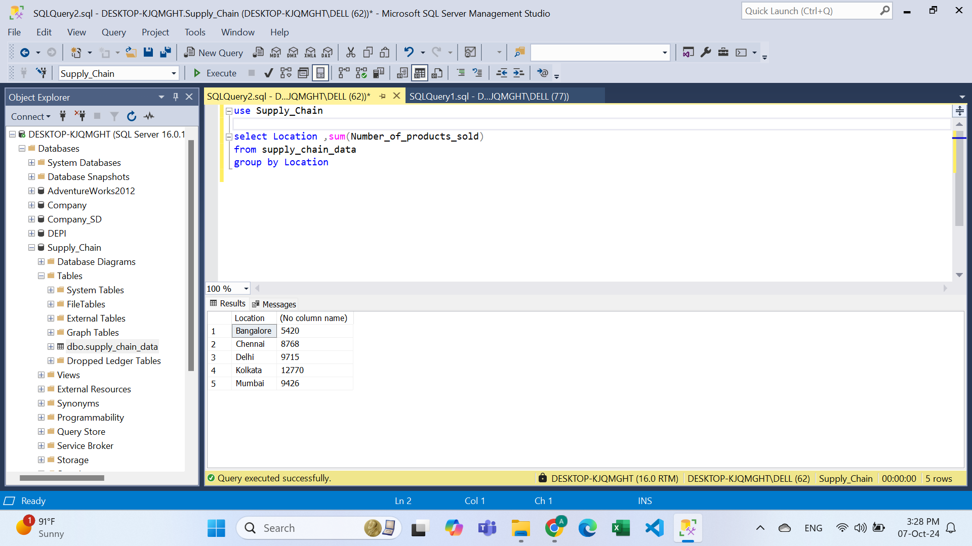

**Tableau:**

